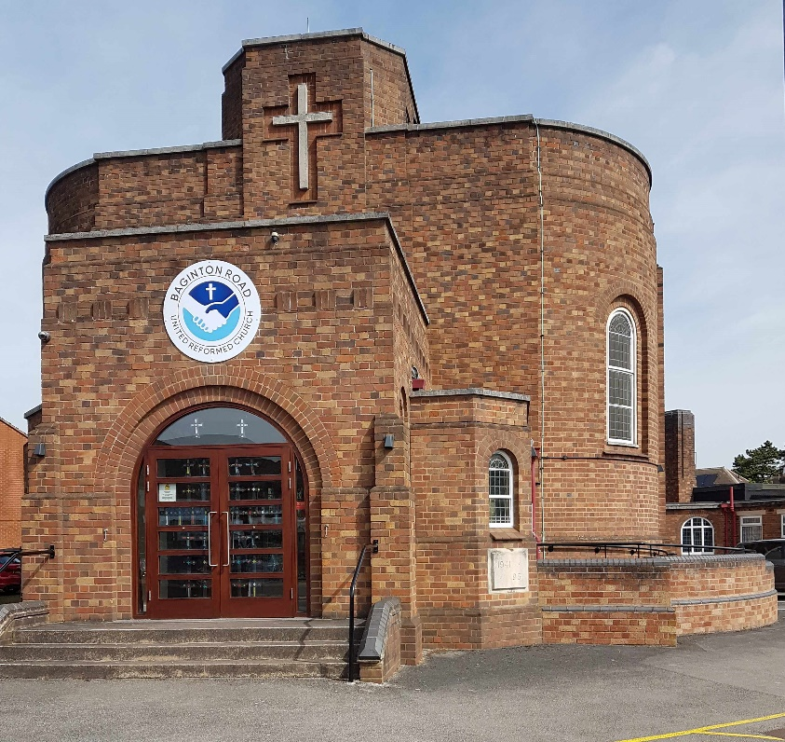

Baginton Road United Reformed Church
Holiday from Home
Monday 15 August 2022
Tuesday 16 August 2022
Wednesday 17 August 2022

Join us for our mini break. A warm welcome awaits.

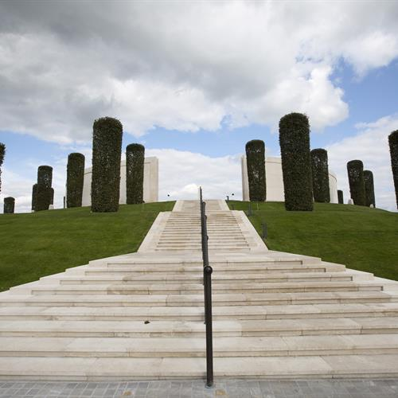

Monday 15 August 2022.
Today is the day of our coach trip to the National Memorial Arboretum, Staffordshire with optional Land Train tour at 11.30am.
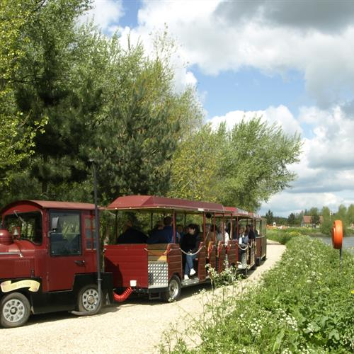
The coach leaves Warwick Road Church Centre at 9.30am and Baginton Road URC at 9.45am and returns approximately 3.30pm. Please make provision for your own lunch.
The 150-acre site features approximately 400 memorials and 25 000 trees as a tribute to those who have served and continue to serve our country. There is a restaurant, coffee shop and gift shop. A network of paths makes it accessible for those with special needs. Mobility scooters may be hired but advanced booking is advised.
Please note: Limited spaces available

Tuesday 16 August 2022 and Wednesday 17 August 2022.
Activity Days
These days will consist of different activities taking place at the West Orchard Centre, Baginton Road URC, Coventry. The days will run from 10.00am to 3.30 pm and will include lunch with plenty of tea, coffee, biscuits, cakes and chat.

The activities will include a selection from:
Pottery
Visit from the Guide Dogs for the Blind
Nail Painting Keep Fit
Card Making Flower Arranging
Silk Painting Scratch Pictures
Bookmarks and more…………

To book please complete the enclosed form and send/give it to
Kevin Bodsworth
Administrator
Baginton Road URC
83 Baginton Road
Coventry
CV3 6FP
Phone 024 7641 9927

Email: westorchardoffice@gmail.com
Cheques to be made payable to West Orchard URC

Holiday from Home Booking Form
Name…………………………………………………………………………………………………..
Address……………………………………………………………………………………………..
Contact Telephone number…………………………………………………………….
Emergency Contact number…………………………………………………………..

Please book me ………. tickets for the coach trip on Monday 15 August. Cost £10 per person £………..
Please book me ………. tickets for the optional Land Train trip on 15 August. Cost £5 per person £………..
Please book me ………. places for the Activity Day on Tuesday 16 August. Cost £5 per person including lunch £…………
Please book me …. places for the Activity Day on Wednesday 17 August. Cost £5 per person including lunch £…………
Total Cost £…………
Please note. This data will be destroyed after the event

Holiday from Home Booking Form
Name…………………………………………………………………………………………………..
Address……………………………………………………………………………………………..
Contact Telephone number…………………………………………………………….
Emergency Contact number…………………………………………………………..

Please book me ………. tickets for the coach trip on Monday 15 August. Cost £10 per person £………..
Please book me ………. tickets for the optional Land Train trip on 15 August. Cost £5 per person £………..
Please book me ………. places for the Activity Day on Tuesday 16 August. Cost £5 per person including lunch £…………
Please book me …. places for the Activity Day on Wednesday 17 August. Cost £5 per person including lunch £…………
Total Cost £…………
Please note. This data will be destroyed after the event

