

Baginton Road URC
Holiday from Home 2026

Monday 3rd – Wednesday 5th August 2026

Join us for our mini break. A warm welcome awaits you!

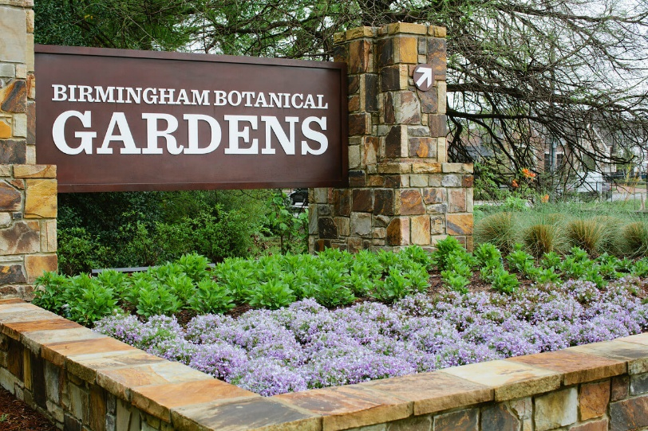

Tuesday 4th August 2026 - today is the day of our coach trip to The Birmingham Botanical Gardens. Cost £20 per person including entry to the gardens.
The coach leaves Baginton Road URC at 9.15am and picks up at Warwick Road Church Centre at 9.30am. The coach will leave The Gardens at 3pm.
Refreshments and lunch can be purchased in the café “Medicine Bakery at the Gardens” or bring a picnic.
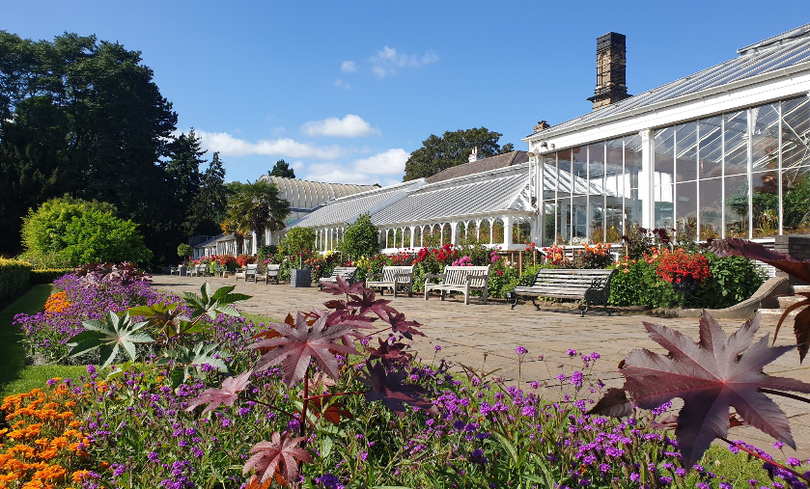
Please note: Limited spaces available so you must pay when booking.

Monday 3rd August 2026
Wednesday 5th August 2026
Activity Days
Cost £10 each day and per person

These days will consist of different activities taking place at Baginton Road URC, Coventry. The days will run from 10.00am to 3pm and will include lunch with plenty of tea, coffee, biscuits, cakes and chat.
There will be a wide range of activities.
On both days there will be a selection of different crafts as well as quizzes and a chance to play popular board games. All activities are optional, and people can choose what they want to do.
Tea and coffee will be available, and lunch served both days.




To book please complete the enclosed form and send/give it to

Church Office
Baginton Road URC
Baginton Road
Coventry
CV3 6FP
Phone 024 7641 9927

Email: office@bagintonroadurc.org.uk
If possible, please pay by cheque or bank transfer.
Cheques to be made payable to West Orchard URC
Bank transfers to Sort Code 40-52-40 Account 00015036 (Please put your family name and HFH26 in reference).



Holiday from Home 2026 Booking Form

Name________________________________________
Address______________________________________
______________________________________________
Contact Telephone number_________________________
Emergency Contact number_________________________

Please book me ____ place(s) for the activity day on
Monday 3rd August. Cost £10 per person. £ ____

Please book me ____ ticket(s) for the coach trip on
Tuesday 4th August. Cost £20 per person. £ ____

Please book me ____ place(s) for the activity day on
Wednesday 5th August. Cost £10 per person. £ ____

Total Cost £ ____

